PSG COLLEGE OF TECHNOLOGY, COIMBATORE – 641 004
Department of Applied Mathematics and Computational Sciences
MSc SOFTWARE SYSTEMS – Semester IV
20XW48 – Web Designing Lab
PROBLEM SHEET – CSS3 Basics

- Write a CSS rule to a web page with a background color (light gray) and a color (dark blue).

<html>
<style>
body{
background-color:#9e9e9e;
}
p{
color:#0209cc;
}
</style>
<body>
<p>Hello this is CSS</p>
</body>
</html>

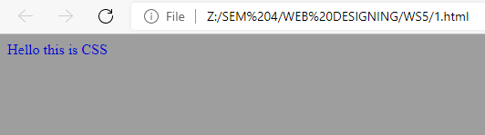
- Write a CSS rule that places a background image halfway down the page, tiling it horizontally and vertically. The image should remain in place when the user scrolls up or down.
- Write the CSS code to display a page with background image with different “repeat” values and another image in the center of the page.
- Create a page with three paragraphs and write the CSS code to put an image as background image in each one of the paragraphs.
- Write a CSS rule to set the background color for block level element. Use different color models like color names, hexadecimal colors, rgb and others.
- Write a CSS code using different text properties to add some special styles to make the headings stand out more from the main text and also make the text in the paragraphs look more clean and attractive.
- Write a CSS rule that makes all text 1.5 times larger than the base font of the system and color it red.
- Create a CSS rule that changes the effect of an EM element from italic text to underlined text.
- Write a CSS rule that changes the color of all elements with attribute CLASS=”greenMove” to green and shifts them down 25 pixels and right 15 pixels.
- Design a webpage with three titles and four paragraph as shown below:
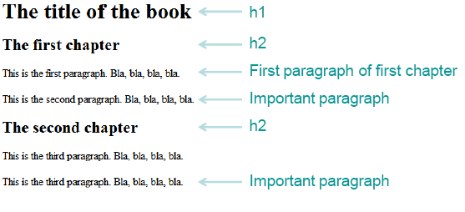
Write the CSS rule as following:
- The main title (h1) is color white on black
- The chapter titles (h2) are blue on yellow
- The default color of paragraphs is green
- The first paragraph of the first chapter is black
- An important paragraph is yellow on red
- Write CSS code to implement the following :
      - Colorize text of a paragraph where RGB value is (51, 204, 0).
      - Put a background image called BKG.GIF behind a single word “TEXT” written with a font size of 39 pixels.
      - Place an image in the background of a page such that the image tiles only in the horizontal direction and the starting position is the horizontal and vertical center of the page.
- Write CSS code to implement the following :
A border around an image element such that the top and bottom borders are 3 pixels wide and of type “dashed” while the left and right borders are 5 pixels wide and of type “solid”. All borders are green in color.
- Write the CSS code for an image 100 by 100 pixels in dimension and place it at the center of a page. Arrange to change the shape of the cursor to a “crosshair” when positioned over the image.
- Use CSS to write the text string “Cascading Style Sheet” dark red in color and in small caps as in a size that approximately covers 50% of the page width. The text should be a hyperlink pointing to a file STYLE.HTM, but without any underline. The stylesheet should remain in an external file.
- Write the CSS rule to display the webpage as shown below
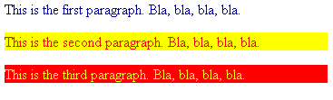

- Replicate the following Web page using CSS
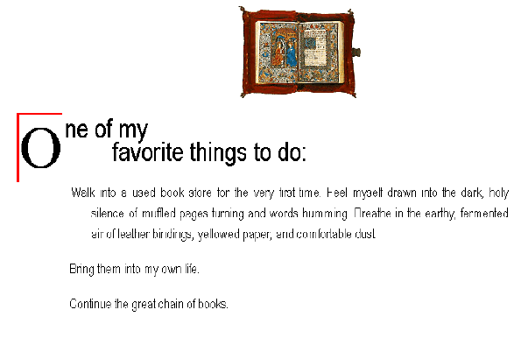
- Write a CSS rule to display the nested list items. The main category list items should be in the ordered list with property value of upper alpha and all sub category list items should be in the unordered list with property value of square.
- Write the CSS following rules for the link in the web page
  - normal and visited state a background-color of #95b7cd and make their text color the same as the regular text on the page
  - links in their hover state a background-color of #aaddee
  - links in their active state a background-color of #3cc7f0
- Create a text shadow on the phrase "New features in CSS3" with a horizontal offset of 2px, a vertical offset of 5px, a blur radius of 6px and a text-shadow color deepskyblue.
- Create a div element with a width and height of 500px. Create a diagonal linear gradient using the colors of the rainbow—Red, Orange, Yellow, Green, Blue, Indigo, Violet.
- Create a div element with a width and height of 500px. Create a radial gradient with three colors. Start the gradient in the bottom-left corner with the colors changing as they move along the gradient line to the right.

- Write the CSS code for below webpage:
